1. Run service arsrvc_upb_admn in SICF transaction. Sap->bc->ui5_ui5->sap-> arsrvc_upb_admn

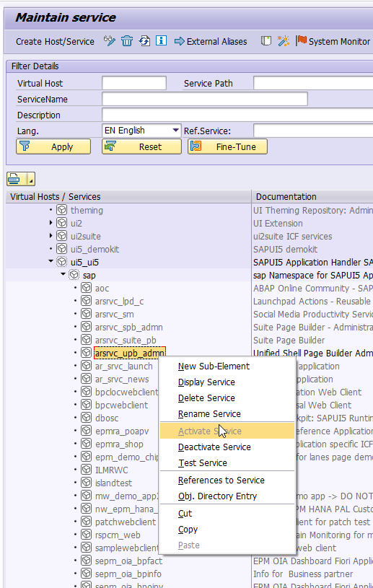

1. Run transaction /UI2/FLPD_CUST or open direct link in WebBrowser: <https://kde.na.pg.com:44302/sap/bc/ui5_ui5/sap/arsrvc_upb_admn/main.html#/Catalog/X-SAP-UI2-CATALOGPAGE:/UI2/FLP_ADMIN>

In case of error do step 3 :

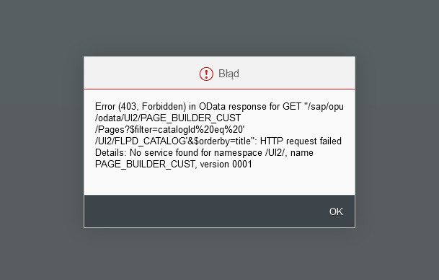

Correct page looks similar to this:

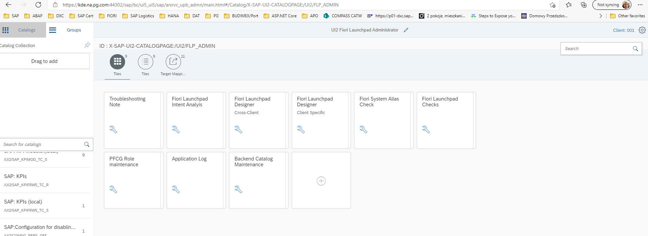

1. Configure services according to note number: 2420336 - No service found for namespace /UI2/, name <SERVICE_NAME>
   1. Run the /IWFND/MAINT_SERVICE or /n/IWFND/MAINT_SERVICE stransaction
   2. Click the button „Add service”

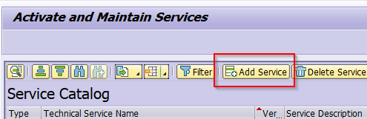

* 1. Enter your system alias in the "System Alias" field, enter the namespace and service name in the "Technical Service Name" field (for example, /UI2/INTEROP), click "Get Services"

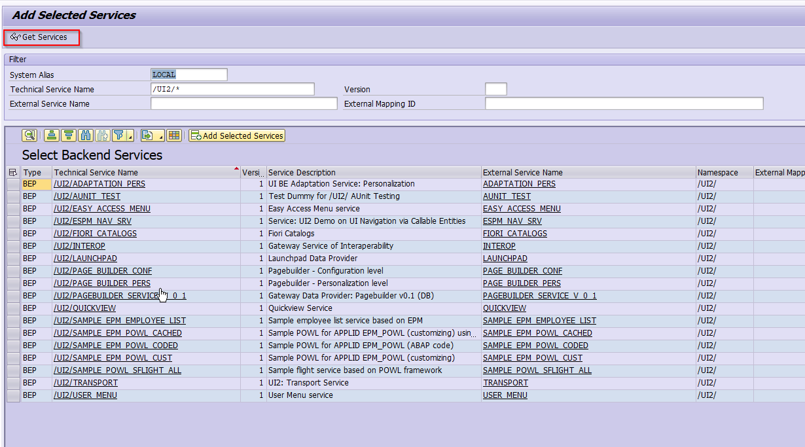

* 1. Select the service by clicking the grey box to select the row and click the button „Add selected services”

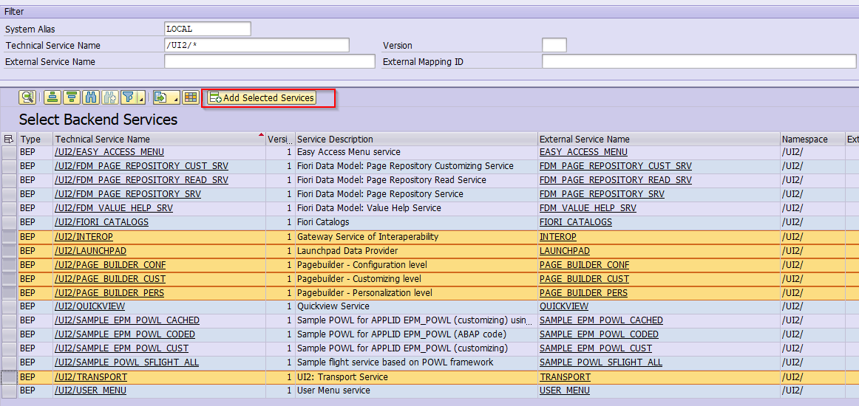

* 1. Fill out the blanks in the popup and press the green checkmark

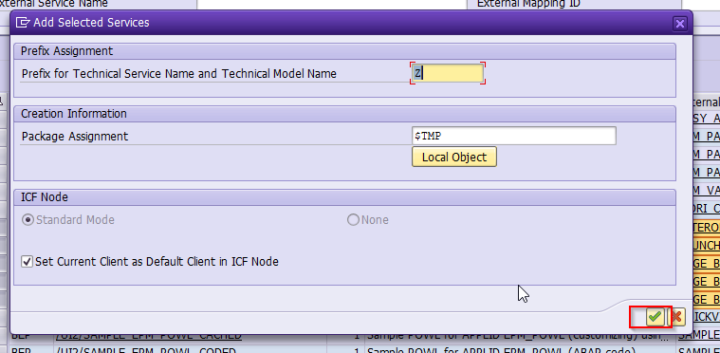

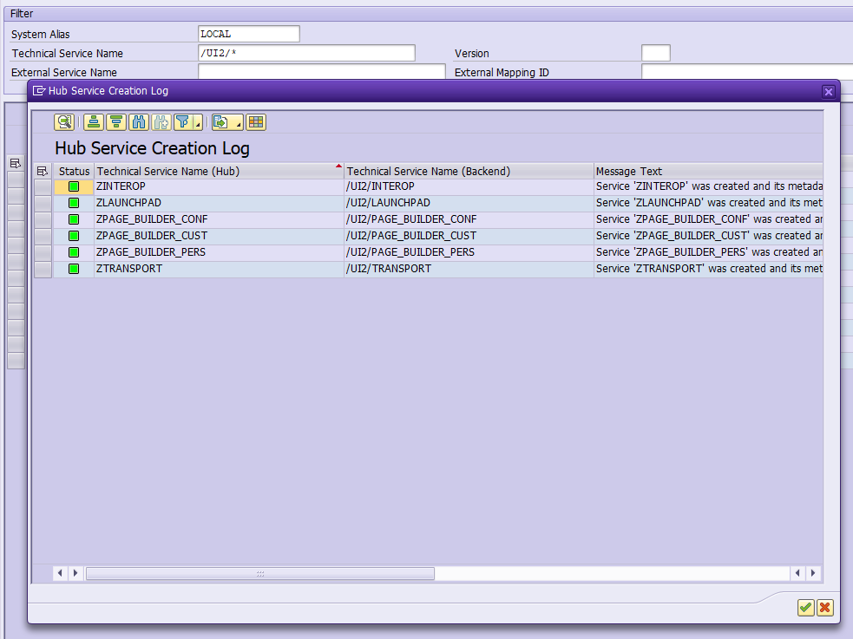

1. Create catalog and group in fiori launchpad, use link <https://kde.na.pg.com:44302/sap/bc/ui5_ui5/sap/arsrvc_upb_admn/main.html#/Catalog/X-SAP-UI2-CATALOGPAGE:/UI2/FLP_ADMIN> or run transaction /UI2/FLPD_CUST

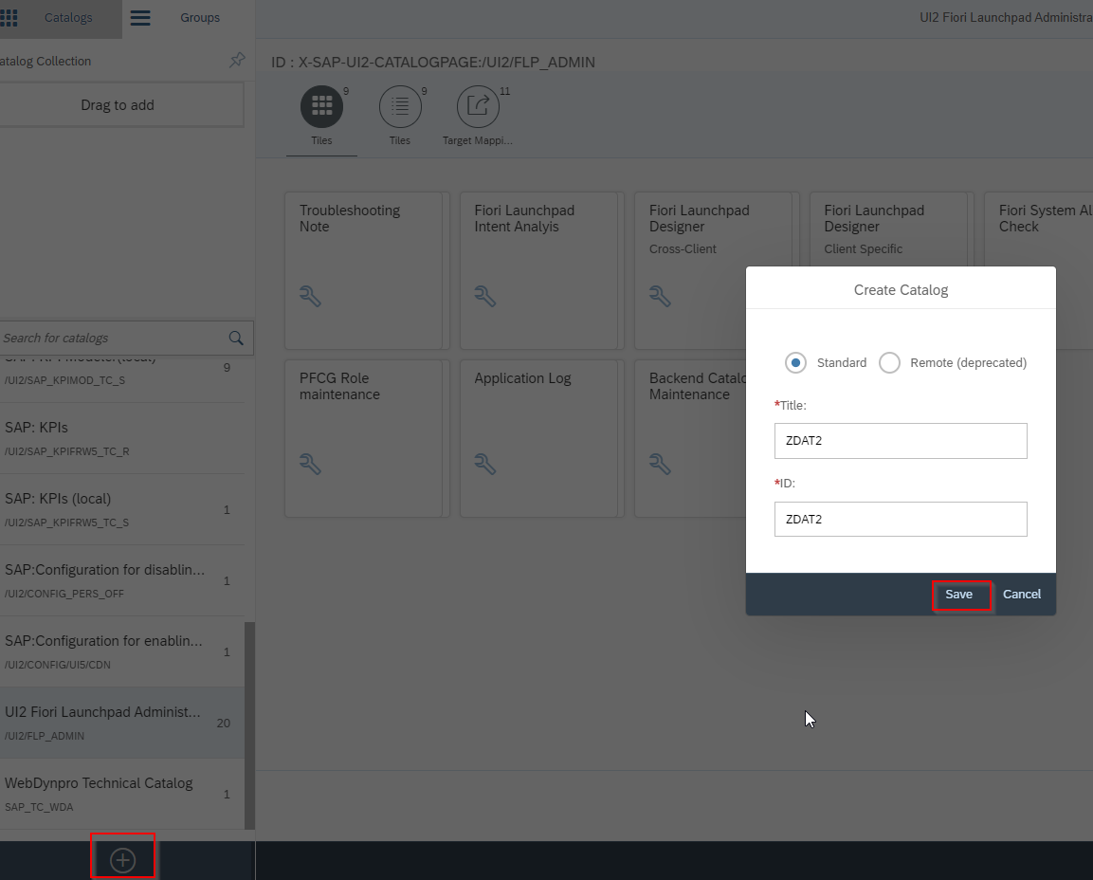

1. Create semantic object, transaction /UI2/SEMOBJ

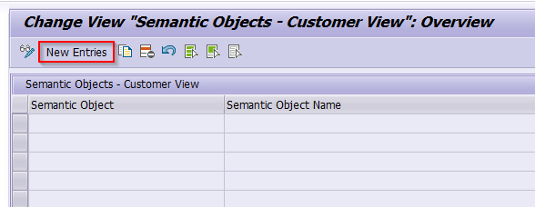

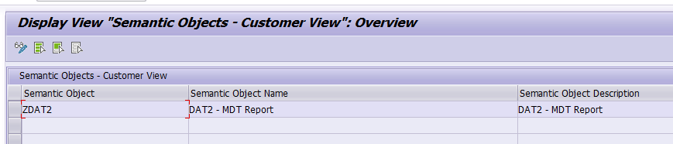

1. IF /UI2/SEMOBJ not working try ‘/n/UI2/SEMOBJ’.

Also if you are not authorized to use this transaction –

SM30

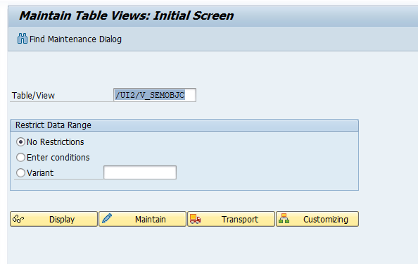

Maintain – Create Entries –



Save to the WorkBench TR

1. Create target mapping. If errors occurs reset buffers (transactions: **/IWFND/CACHE_CLEANUP and /IWBEP/CACHE_CLEANUP)**and recreate target mappings.

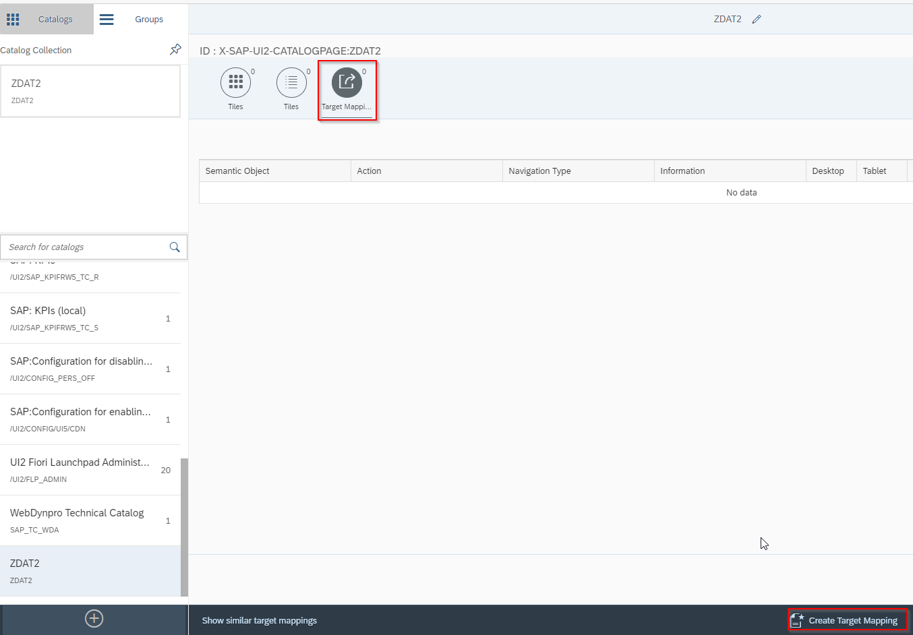

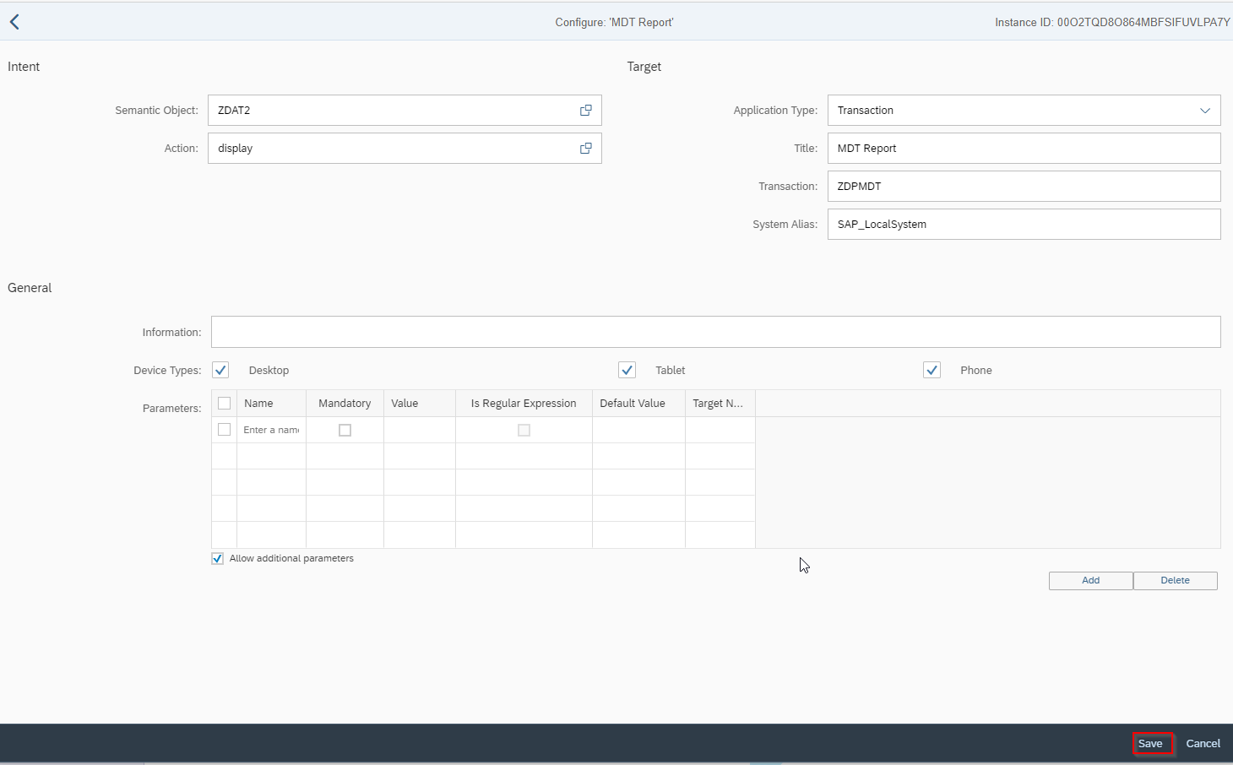

1. Assign Target mapping to Tile

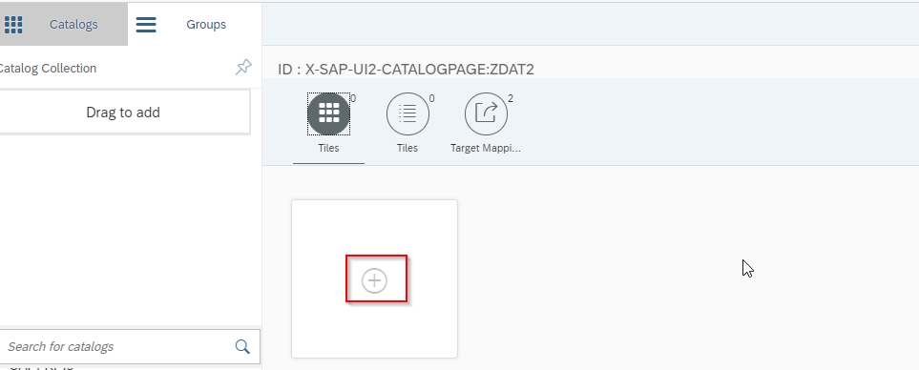

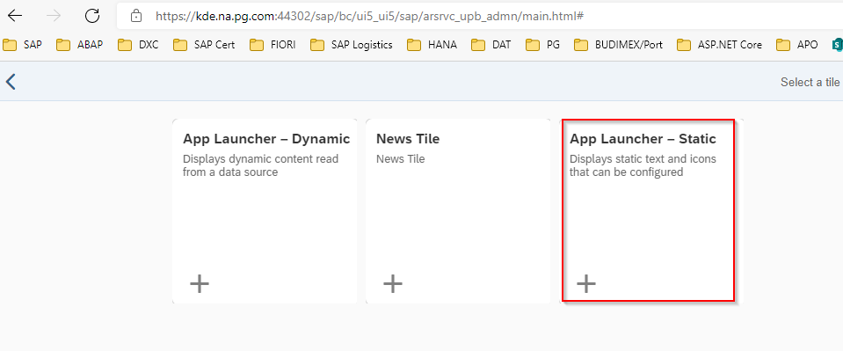

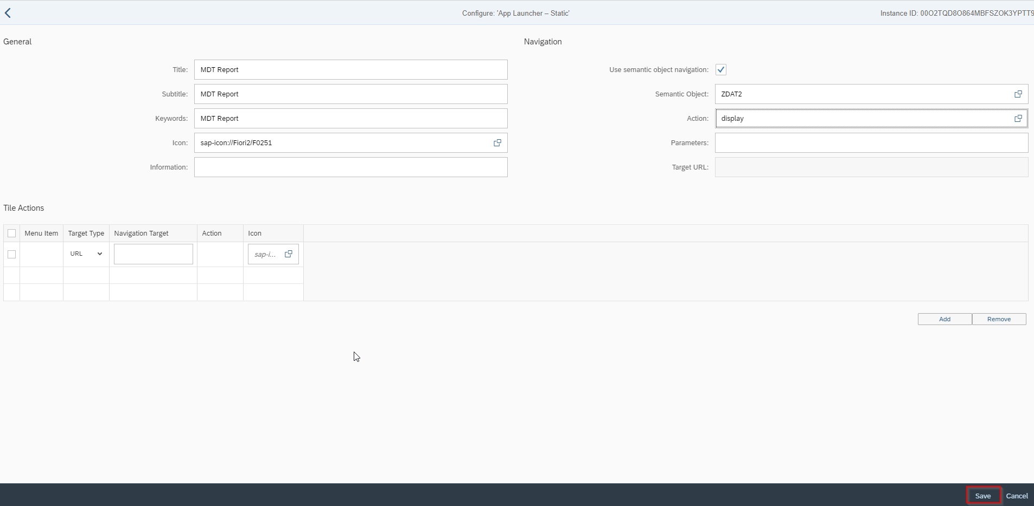

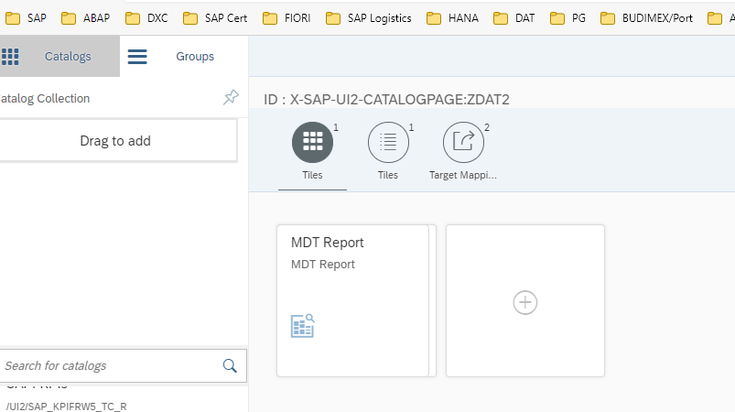

1. Add new group

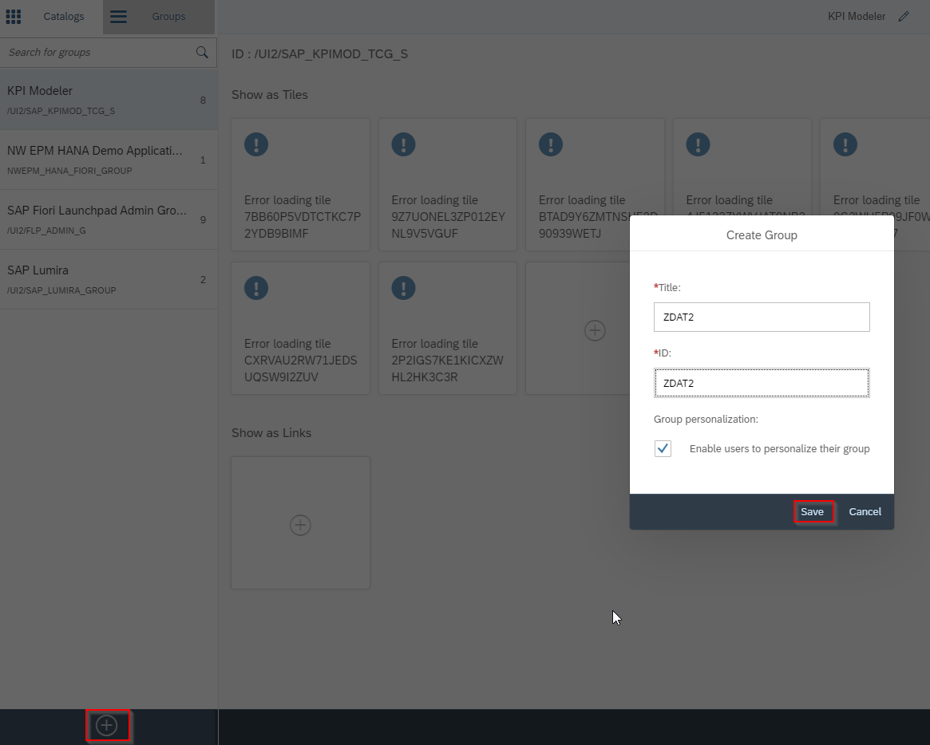

1. Assign tile to group

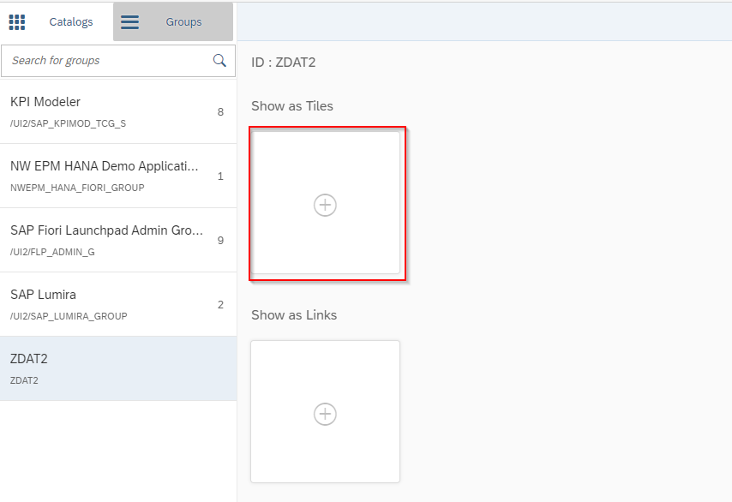

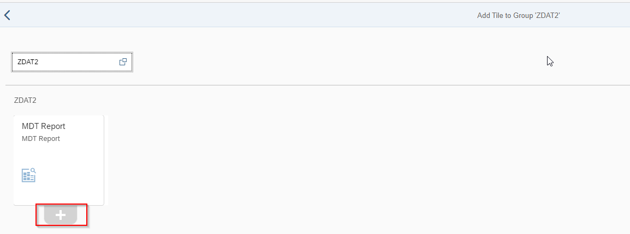

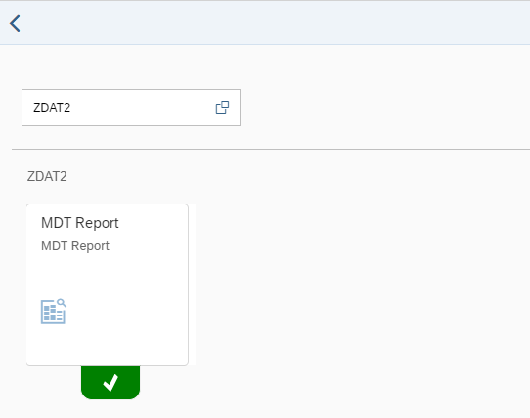

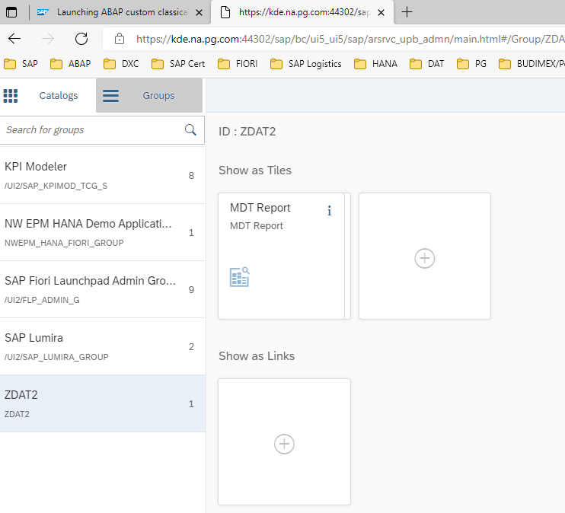

1. Configure roles – add new role in transaction PFCG

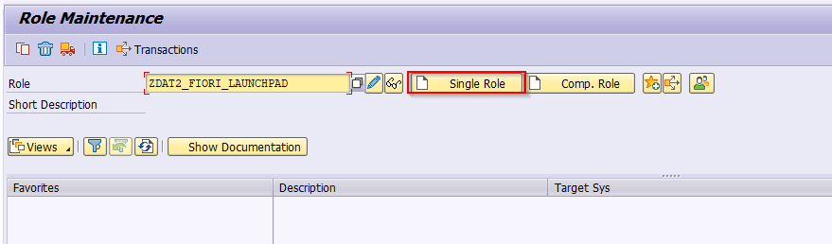

Add Tile to role

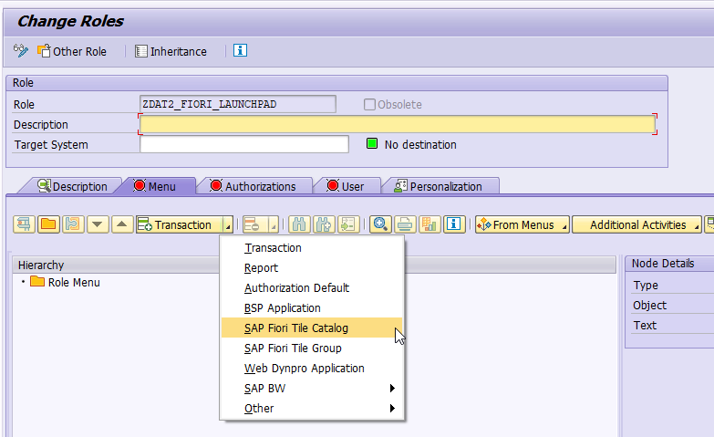

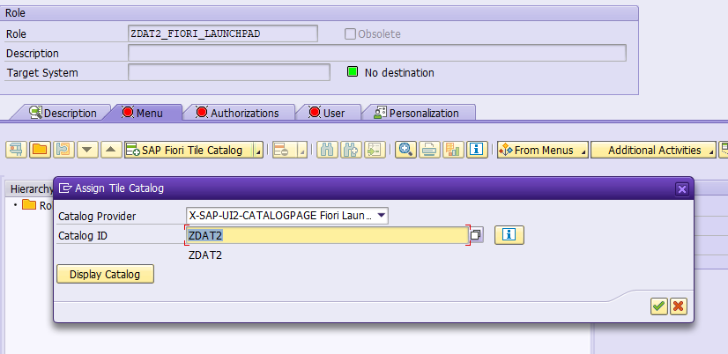

Add Group to role

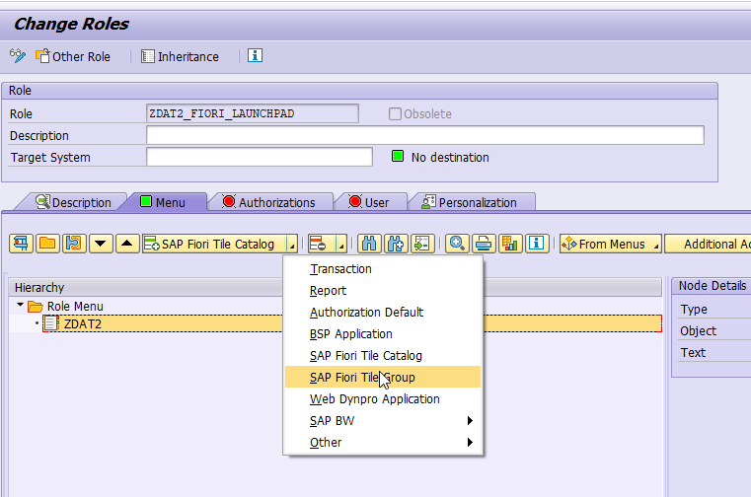

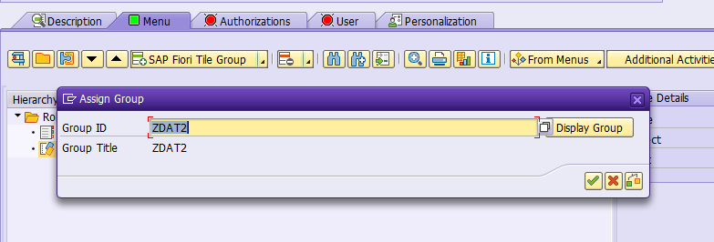

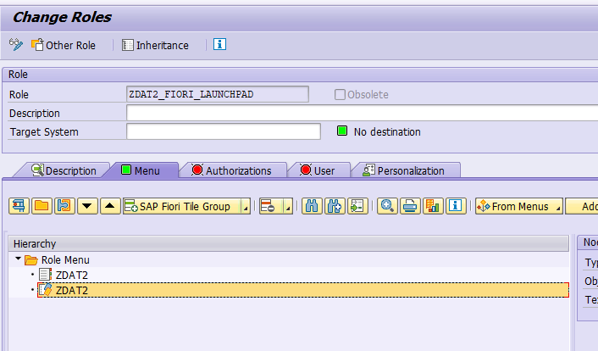

1. Assign role to user – transaction SU01

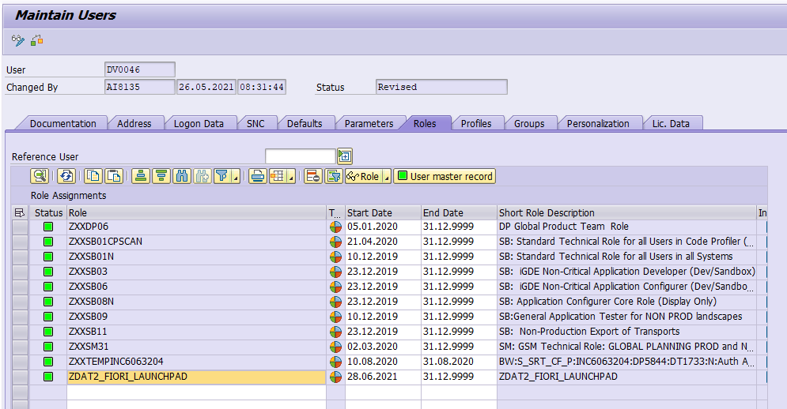

1. Run Fiori Launchpad service. Run service flp in SICF transaction. Sap->bc->ui2->flp

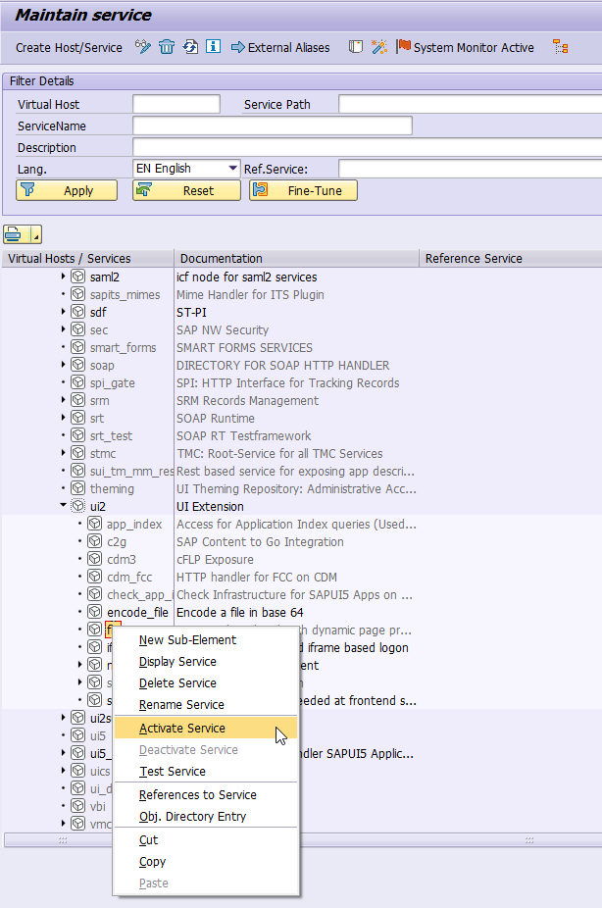

1. Launch Fiori - transaction /UI2/FLP

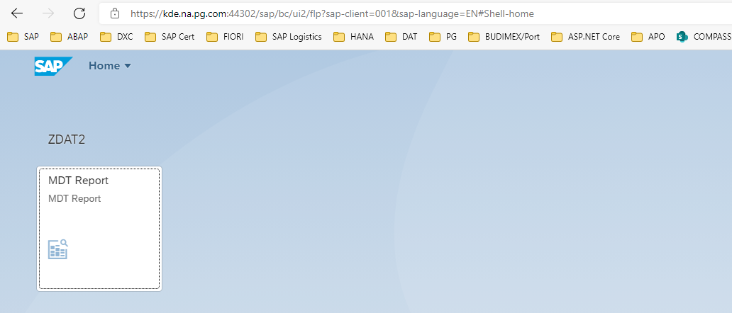

1. Run report

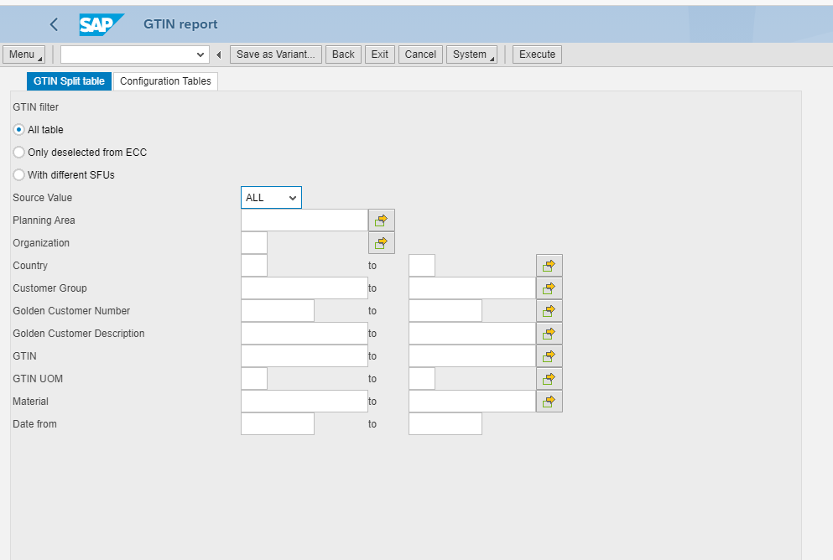

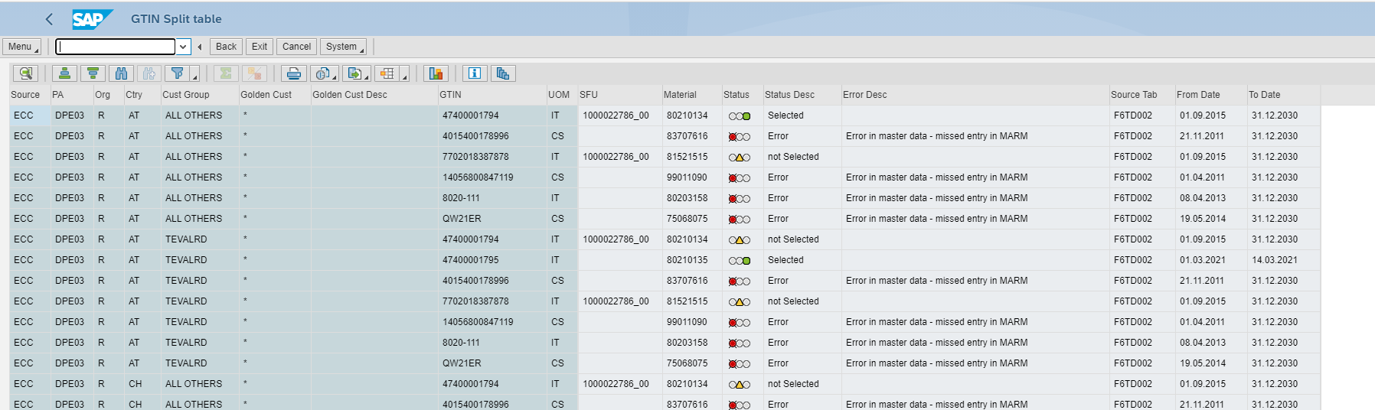

Additional link:

<https://blogs.sap.com/2016/09/06/launching-abap-custom-classical-report-in-fiori-launchpad/>

How to add link to DAT2.

1. Add new Tile without semantic object

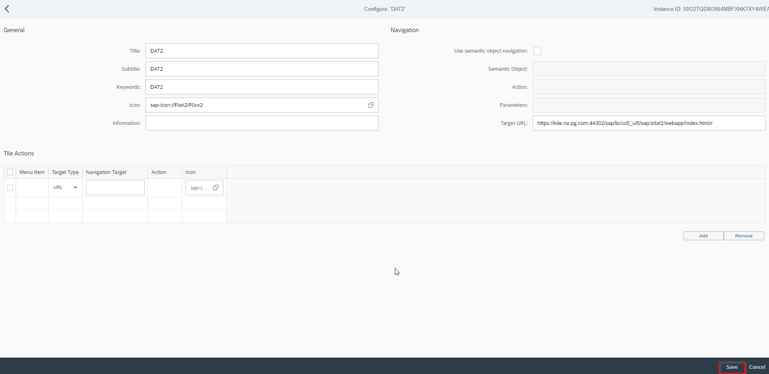

1. Assign new Tile to group ZDAT2

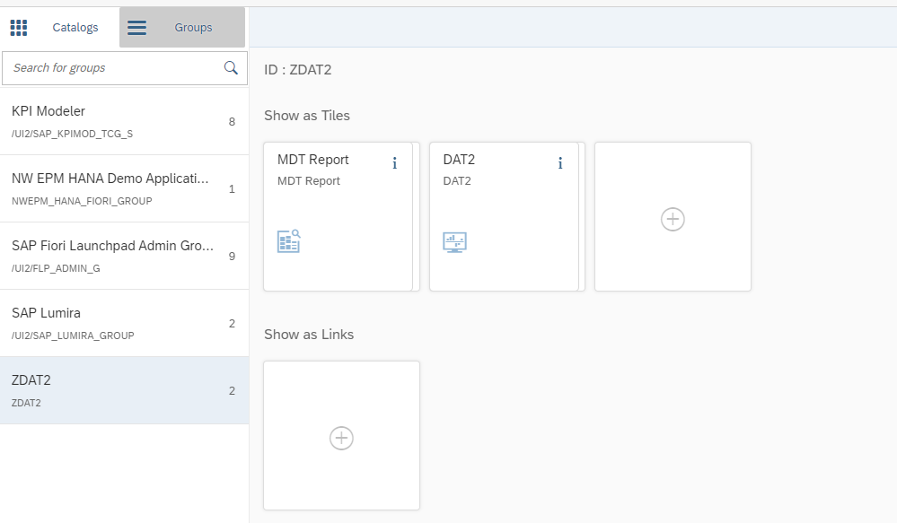

1. Run Launchpad

